**Object relational diagram:**

**No of entities:**

* 1. Customer entity
* 2. Invoice entity
* 3. Line_Item entity **Relationship:**
* 1. There are M:1 relationship between Invoice entity and Customer entity
* 2. There are 1:M relationship between Invoice entity and Line_Item entity

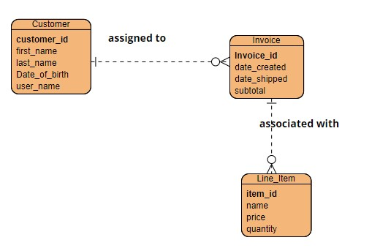

**NoSQLStructure:**

{

"customer_id": ObjectID,

"first_name": String,

"last_name": String,

"Date_Of_birth": String,

"user_name" : String,

"Invoice":[{

"invoice_id" : ObjectID,

"date_created" : String,

"date_shipped" : String,

"subtotal" : decimal, "Line_Item: [{

"Item_id: : ObjectID,

"name" : String,

"price" : decimal,

"quantity" : integer

]}

]}

}

**NoSQL with some data**

{

"customer_id": 101,

"first_name": 'BOB',

"last_name": 'Smith',

"Date_Of_birth": '12-04-1996',

"user_name" : 'Bob123',

"Invoice":[{

"invoice_id" : 11,

"date_created" : '2-05-2020',

"date_shipped" : '5-05-2020',

"subtotal" : 560.40, "Line_Item: [{

"Item_id: : 34,

"name" : 'Jeans pent',

"price" : 500.40,

"quantity" : 1

]}

]}

}